EXP 6 framing – Byte Stuffing and Bit Stuffing

Date: 7th September 2026

AIM: Implementation of framing – Byte Stuffing and Bit Stuffing

Theory:

*Write about framing methods with examples and the difference between – Byte Stuffing and Bit Stuffing 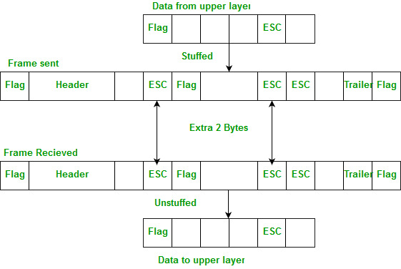

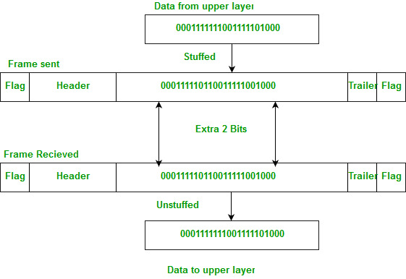

Conclusion:

References:
Difference between Byte stuffing and Bit stuffing - GeeksforGeeks
Prentice Hall - Computer Networks Tanenbaum 4ed.pdf

